Purple Bench Project
About the Purple Bench Project
The Purple Bench Project supports the installations of a series of purple benches in public spaces to honour all victims killed as a result of domestic and family violence (DFV). The purple bench initiative began in Canada in 2015. In Nova Scotia, Canada, purple benches are located in public parks to honour the memory of women murdered by their partner and to provide help numbers for people experiencing DFV. They are known as Barb’s Benches and were launched in 2015 to mark the 25-year anniversary of the murder of Barb Ballie by her husband.
The Purple Bench Project in WA
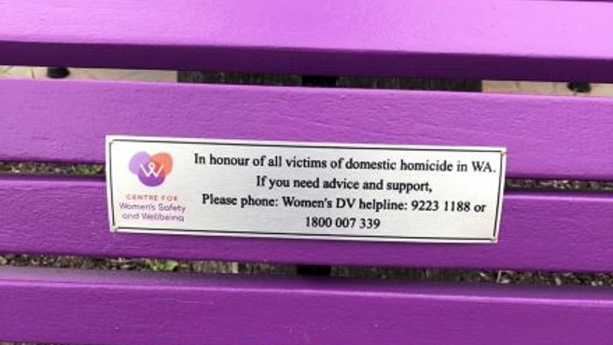
The Purple Bench Project was bought to Western Australia (WA) by the Women’s Council for Domestic and Family Violence Services WA, the previous peak body for domestic and family violence services, now known as Centre for Women’s Safety and Wellbeing (CWSW).
The first bench in WA was launched by the Hon. Simone McGurk, MLA - Minister for Child Protection; Women’s Interests; Prevention of Family and Domestic Violence; Community Services and Dr Brad Pettit - Mayor, City of Fremantle in 2018. Since then, many purple benchs have been installed throughout WA, with the initiative being supported by Local Government and Members of Parliement.
The project has become a prominent place-based initiative which honours victims killed as a result of DFV, raises awareness of DFV in the community and provides the details of crisis phonelines that can provide assistance.
The Purple Bench Project does not currently receive any funding. This means registrants are responsible for funding their local Purple Bench Project. CWSW provide in-kind support for registrants by providing the information required to successfully install and launch their Purple Bench.
Purple is associated with the global Domestic Violence Awareness Movement

Purple Bench Registration
Our local Council / Organisation / plan to (PLEASE SELECT ONE):
☐ Purchase a new bench with heavy duty aluminium slats, powder coated in 'Dark Violet’ (Must be ‘Parkway seat’ from Exterior Street and Park Outfitters - 1300 785 765)
☐ Renovate an existing bench using Dulux 'Purple Wisdom' and add the plaque

Responsibility Acknowledgement
☐ We acknowledge there is a cost for the Purple Bench and commemorative plaque and are prepared to pay for these expenses.
☐ We will find a suitable location for the bench with maximum exposure.
☐ We will send out a letter of invitation to our nominated local council/organisation representative for the launch.
☐ We will ensure the plaque reads:
"In honour of all victims of domestic homicide in WA. If you need advice and support, please phone: Women’s DV helpline: 9223 1188 or 1800 007 339"
(*refer to image on first page)
☐ We will ensure the local council/organisation and CWSW logos are on the plaque.
☐ We will hold a launch and invite local members of government and local DFV related service providers.
☐ We recognise that any media and information about the Purple Bench will be public information.

We acknowledge CWSW is only responsible for:
- Providing the CWSW logo in suitable format, appropriate wording for the plaque and the required specifications for the bench.
- Providing a list of key local domestic and family violence specialist services that you may wish to consider inviting to the bench launch.

Purple Bench Registration Details
Date:
Registering Organisation:
Name of Contact:
Phone:
Email:

Where will the Purple Bench be located?

How did you hear about The Purple Bench Project?

Thank you for registering your interest. A representative from CWSW will be in contact as soon as possible.

CWSW support contact: info@cwsw.com.au Phone: (08) 9420 7264

