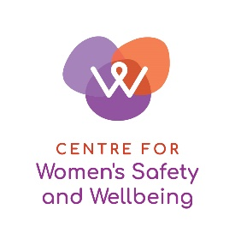
Centre for Women’s Safety and Wellbeing

Elected Board Member Nomination Form 2022

The Centre for Women’s Safety and Wellbeing is the peak representative body for women's family and domestic violence, sexual assault and community-based women’s health services in Western Australia. Our purpose is to lead, influence and advocate for women’s safety, health and wellbeing, and to promote gender equality.
Nominee details
Name
Organisation
Mailing address
Phone number
Email address

My organisation provides (please mark with an X):

- Domestic and Family Violence Services
- Sexual Assault Services
- Women’s Community Health Services

I am nominating to represent (please mark with an X):

- Domestic and Family Violence Services
- Sexual Assault Services
- Women’s Community Health Services

The CWSW objectives are to:

advocate, influence and collaborate to improve outcomes in the prevention of, and responses to, violence against women and their children, sexual assault/abuse, women’s health and gender equity.

lead and enhance the capacity of services to meet the safety, health and wellbeing needs of women and their children in the Western Australian community.

provide policy advice and monitor policies, legislation, programs and practices which impact on women’s safety, capacity for good health, access to justice and economic security.

be a knowledge translation and exchange centre for violence against women and their children, sexual assault/abuse, gender equity, and the promotion of women’s health and wellbeing, with strong roots in policy, practice, academic and community networks.

identify significant issues and raise public awareness of all aspects of violence against women and their children, sexual assault/abuse, gender inequity and the social determinants of women’s health.

ensure that the activities of the Association are responsive to the needs of women and their children that may be disadvantaged because of multiple and intersecting forms of discrimination and inequity.

provide assistance, information and referral to enable women and children in crisis to access the vital resources they require.
Please answer the following questions:
Why are you interested in a position on the CWSW Board?
What skills and experience in Domestic and Family and/or Sexual Violence and/or Women’s Health policy and practice do you bring to the Board?

I acknowledge that by signing this form I endorse the purpose, objectives and values of the CWSW, and agree to comply with the Constitution.

I confirm that I am an Authorised Individual of a Full Member of the Centre for Women’s Safety and Wellbeing Inc, and I am nominating for the Board of Management.

Signature

Date

Please return this form by email to Rebecca Smith, Chief Executive Officer
at rebecca.smith@cwsw.org.au by 19 October 2022

